**EXCELL ASSIGNMENT – 9**

**QUESTION 1. What are the different margins options and do we adjust the margins of the excel worksheet?**

**ANSWER=**   
In Microsoft Excel, margins refer to the space around the edges of a printed page. Adjusting the margins in an Excel worksheet can be useful when you want to control the layout and appearance of the printed document. You can access margin settings when preparing to print a worksheet. Here are the different margin options and how to adjust them:

**Different Margin Options:**

1. **Normal Margin:**
   * This is the default margin setting. It provides a standard margin size for the top, bottom, left, and right edges of the page.
2. **Narrow Margin:**
   * This option reduces the margin size, allowing more content to fit on the page. It is useful when you want to maximize the use of space on the printed page.
3. **Wide Margin:**
   * This option increases the margin size, providing more space around the edges of the page. It can be helpful when you want to create a document with a more spacious layout.
4. **Custom Margin:**
   * With the custom margin option, you can manually set the margin size for the top, bottom, left, and right sides of the page according to your specific requirements.

**Adjusting Margins in Excel:**

To adjust the margins in Excel, follow these steps:

1. **Page Layout Tab:**
   * Go to the "Page Layout" tab on the Excel ribbon.
2. **Margins Dropdown:**
   * In the "Page Setup" group, you will find the "Margins" dropdown menu.
3. **Select Margin Option:**
   * Click on the dropdown menu to reveal the different margin options: Normal, Narrow, Wide, and Custom.
4. **Custom Margins:**
   * If you choose "Custom Margins," the Page Setup dialog box will appear. Here, you can manually enter values for the top, bottom, left, and right margins.
5. **Apply Margins:**
   * Once you've selected the desired margin option or customized the margins, click the "OK" button to apply the changes.

Adjusting margins is especially important when you need to fit your Excel data onto a specific number of pages or when you want to control the spacing around the printed content. It helps ensure that your printed documents look as intended and are easy to read.

Top of Form

**QUESTION 2.** **Set a background for your table created.**

**ANSWER=**

Make sure that only one worksheet is selected. On the Page Layout tab, in the Page Setup group, click Background. Select the picture that you want to use for the sheet background, and then click Insert.

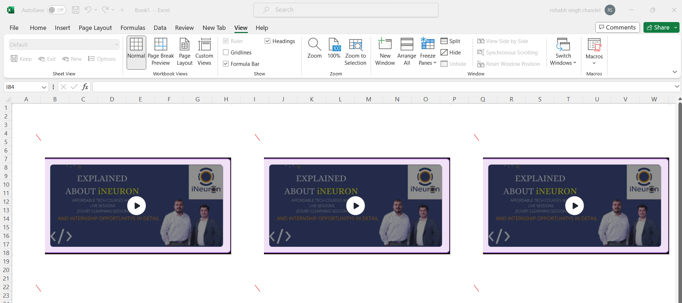

**QUESTION** **3. What is freeze panes and why do we use freeze panes? Give**

**examples.**

**ANSWER=**

Freeze Panes is a feature in Microsoft Excel that allows you to lock specific rows or columns in place while scrolling through a large dataset. This feature is particularly useful when working with extensive spreadsheets, as it helps keep headers or important information visible as you navigate through the data. Freezing panes can enhance readability and make it easier to understand the relationships between different parts of the spreadsheet.

**Why Do We Use Freeze Panes:**

1. **Header Visibility:**
   * Freeze Panes is commonly used to keep column and row headers visible while scrolling through large datasets. This ensures that the headers, which describe the content of the columns and rows, remain visible at all times, providing context to the data.
2. **Comparing Data:**
   * When comparing data in large tables, freezing panes allows you to keep reference points visible. For example, if you have a long list of products and their sales figures, freezing the header rows can help you see which product corresponds to which column as you scroll.
3. **Entering Data:**
   * When entering data into a large table, freezing panes can be helpful to keep the header row and column visible, providing context for the data being entered.
4. **Data Analysis:**
   * Freeze Panes can aid in data analysis, especially when working with complex models or datasets. Keeping certain rows or columns visible while scrolling allows for a more efficient analysis of relationships and trends.

**QUESTION 4. What are the different features available within the Freeze Panes**

**Command.**

**ANSWER=**

1.**Freeze Top Row:**

* + Description: This option freezes the top row of the spreadsheet, keeping it visible while scrolling through the rest of the data.
  + How to Access: Go to the "View" tab, click on "Freeze Panes," and choose "Freeze Top Row."

1. **Freeze First Column:**
   * Description: This option freezes the leftmost column of the spreadsheet, making it visible as you scroll horizontally through the data.
   * How to Access: Go to the "View" tab, click on "Freeze Panes," and choose "Freeze First Column."
2. **Freeze Panes:**
   * Description: This option allows you to freeze both rows and columns based on the selected cell. Rows above and columns to the left of the selected cell are frozen, providing a reference point while scrolling.
   * How to Access: Select the cell below the rows and to the right of the columns you want to freeze. Go to the "View" tab, click on "Freeze Panes," and choose "Freeze Panes."
3. **Unfreeze Panes:**
   * Description: This option unfreezes any frozen rows or columns, allowing the entire sheet to scroll freely without any locked panes.
   * How to Access: Go to the "View" tab, click on "Freeze Panes," and choose "Unfreeze Panes."

**How to Use the Features:**

1. Freeze Top Row:
   * Select the row below the row you want to freeze.
   * Go to the "View" tab.
   * Click on "Freeze Panes" and choose "Freeze Top Row."
2. Freeze First Column:
   * Select the column to the right of the column you want to freeze.
   * Go to the "View" tab.
   * Click on "Freeze Panes" and choose "Freeze First Column."
3. Freeze Panes:
   * Select the cell below the rows and to the right of the columns you want to freeze.
   * Go to the "View" tab.
   * Click on "Freeze Panes" and choose "Freeze Panes."
4. Unfreeze Panes:
   * Go to the "View" tab.
   * Click on "Freeze Panes" and choose "Unfreeze Panes."

**QUESTION 5. Explain what the different sheet options present in excel are and what**

**they do?**

**ANSWER=**

1**.**Sheet Name:

* + Description: The sheet name is the label that appears on the sheet tab at the bottom of the Excel window.
  + How to Access: Double-click on the sheet tab to edit the name.

1. Tab Color:
   * Description: You can assign a color to the sheet tab to make it visually distinct from other sheets.
   * How to Access: Right-click on the sheet tab, select "Tab Color," and choose a color.
2. Hide or Unhide Sheets:
   * Description: You can hide sheets to prevent them from being displayed in the workbook. This is useful for organizing and managing large workbooks.
   * How to Access: Right-click on the sheet tab, choose "Hide" or "Unhide," and select the sheet.
3. Protect Sheet:
   * Description: You can protect a sheet to control who can edit or modify its contents. Password protection is optional.
   * How to Access: Right-click on the sheet tab, choose "Protect Sheet," and set a password if desired.
4. Background:
   * Description: You can set a background image or color for a sheet to enhance its appearance.
   * How to Access: Go to the "Page Layout" tab, click on "Background," and choose an image or color.
5. Gridlines:
   * Description: You can toggle the visibility of gridlines on the sheet. Gridlines are the faint lines that separate cells.
   * How to Access: Go to the "View" tab and check or uncheck the "Gridlines" option.
6. Headers and Footers:
   * Description: You can customize headers and footers for printing purposes, including adding page numbers, date, time, and other information.
   * How to Access: Go to the "Insert" tab, click on "Header & Footer," and customize as needed.
7. Zoom Level:
   * Description: You can adjust the zoom level to increase or decrease the size of the sheet on the screen.
   * How to Access: Use the zoom slider in the bottom-right corner of the Excel window or go to the "View" tab and use the zoom options.
8. Sheet View Options:
   * Description: You can control whether or not to display certain elements on the sheet, such as gridlines, headings, and formulas.
   * How to Access: Go to the "View" tab and use the options in the "Show" group.
9. Page Layout View:
   * Description: This view allows you to see how the sheet will look when printed. It displays headers, footers, and margins.
   * How to Access: Click on the "View" buttons in the bottom-right corner of the Excel window and select "Page Layout."

These sheet options provide flexibility and customization to meet your specific needs when working with Excel worksheets. They help you organize, protect, and enhance the visual presentation of your data.

Top of Form